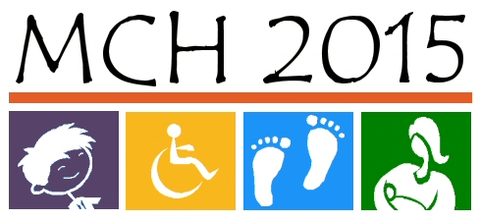

Priorities for MCH 2015 Needs Assessment:
Child and Youth with Special Health Care Needs

- Priority: Increase care within the medical home.
Strategies:
- Education (families, providers, students, legislative)
  - Take a lesson from the drug reps and do lunchtime trainings in shifts at the providers office
  - Webinars and other technology
- Train the trainer concept (train family members on PCMH and they can train other families, providers, etc)
- State resource center to support coordination; can make connections and promote support
- Sharing of data across state agencies
- compare programming to reduce duplication of services and identify gaps in services
- Develop a common language for all providers and families…to reduce confusion and misunderstandings of what a medical home is

- Priority: Increase and improve comprehensive support systems that assist CYSHCN throughout their lifespan to achieve maximum potential.
Strategies:
- Data sharing between agencies and providers
- KDHE services as a clearinghouse (re: one stop, one referral)
- Parent/provider education (age and condition specific) on website (FAQ’s) and handouts (brochures)
- Satisfaction survey for parents on website
- Follow up by prior case manger/team leader on transition results and assessed by KDHE
- Collaborate with other state agencies (including Department of Aging) on programs/services available throughout the lifespan and headed by KDHE.

- Priority: Decrease financial impact on families.
Strategies:
- Sliding scale for families
- Negotiate prescription feeds
- Age limitations for services coverage
- increase education and outreach
- Improve communication among agencies providing services; decrease duplication or fill gaps
- Case Managers (regional)
- Enhance telecommunications /EMR
- Annual cap per child

